Dummy Tables and Figures

TABLE 1. Baseline characteristics
 | n (%)
Age (y)
Mean (SD) | xx.x (xx.x)
Range | xx-xx
Sex
Male | xx (xx.x)
Female | xx (xx.x)
Previous surgery/laser
Selective laser trabeculoplasty | xx (xx.x)
Glaucoma drainage device surgery | xx (xx.x)
Other (specify) | xx (xx.x)
Visual acuity (logMAR)
Mean (SD) | x.xx (x.xx)
Range | x-x
Lens status
Phakic | xx (xx.x)
Pseudophakic | xx (xx.x)
Aphakic | xx (xx.x)
Cup-disc ratio
0.3-0.5 | xx (xx.x)
0.6-0.7 | xx (xx.x)
0.8-0.9 | xx (xx.x)
Mean (SD) | x.xx (x.xx)
Range | x.x-x.x
Patients n = xx; eyes n = xx. Age, sex and previous surgery are per patient; the other rows are per eye.
logMAR, logarithm of the minimum angle of resolution; MD, mean deviation.

TABLE 2. Mean IOP and number of glaucoma medications during follow-up
 |  | IOP (mm Hg) |  |  | No. Medications (n)
 | N† | Mean ± SD (Range) | Decrease from baseline [Mean (%)] | P* | Mean ± SD (Range) | P*
Baseline | xx | xx.x ± xx.x (xx-xx) |  |  | x.x ± x.x (x-x)
1 mo | xx | xx.x ± xx.x (xx-xx) | xx.x (xx) | 0.xxx | x.x ± x.x (x-x) | 0.xxx
3 mo | xx | xx.x ± xx.x (xx-xx) | xx.x (xx) | 0.xxx | x.x ± x.x (x-x) | 0.xxx
6 mo | xx | xx.x ± xx.x (xx-xx) | xx.x (xx) | 0.xxx | x.x ± x.x (x-x) | 0.xxx
12 mo | xx | xx.x ± xx.x (xx-xx) | xx.x (xx) | 0.xxx | x.x ± x.x (x-x) | 0.xxx
18 mo | xx | xx.x ± xx.x (xx-xx) | xx.x (xx) | 0.xxx | x.x ± x.x (x-x) | 0.xxx
24 mo | xx | xx.x ± xx.x (xx-xx) | xx.x (xx) | 0.xxx | x.x ± x.x (x-x) | 0.xxx
30 mo | xx | xx.x ± xx.x (xx-xx) | xx.x (xx) | 0.xxx | x.x ± x.x (x-x) | 0.xxx
36 mo | xx | xx.x ± xx.x (xx-xx) | xx.x (xx) | 0.xxx | x.x ± x.x (x-x) | 0.xxx
Last visit | xx | xx.x ± xx.x (xx-xx) | xx.x (xx) | 0.xxx | x.x ± x.x (x-x) | 0.xxx
†Number of eyes at the current follow-up interval.
*P value for the comparison of each interval with baseline (paired t test or Wilcoxon signed-rank test).

TABLE 3. Complications
Complication | n (%)
Intraoperative
Perforation of the trabeculo-Descemet membrane | xx (xx.x)
Postoperative
Early bleb leak | xx (xx.x)
Corneal abrasion | xx (xx.x)
Shallow anterior chamber | xx (xx.x)
Choroidal effusion | xx (xx.x)
Hypotony† | xx (xx.x)
Cataract progression‡ | xx (xx.x)
Hyphema | xx (xx.x)
Other (specify) | xx (xx.x)
Some eyes may have more than one complication.
†Defined as an IOP measurement below 5 mm Hg.
‡Defined as loss of more than 2 lines of Snellen acuity attributed to cataract, or visually significant cataract requiring surgery.

TABLE 4. Postoperative interventions
Intervention | n (%)
Goniopuncture | xx (xx.x)
Laser suture lysis | xx (xx.x)
Bleb needling | xx (xx.x)
Conjunctival resuturing | xx (xx.x)
Other (specify) | xx (xx.x)
Laser or surgical interventions performed to control intraocular pressure or manage complications.

FIGURE 1. Kaplan-Meier survival curves with 95% confidence intervals for the probability of IOP staying within 5 to 21 mm Hg. Numbers of eyes at risk are shown under each panel.
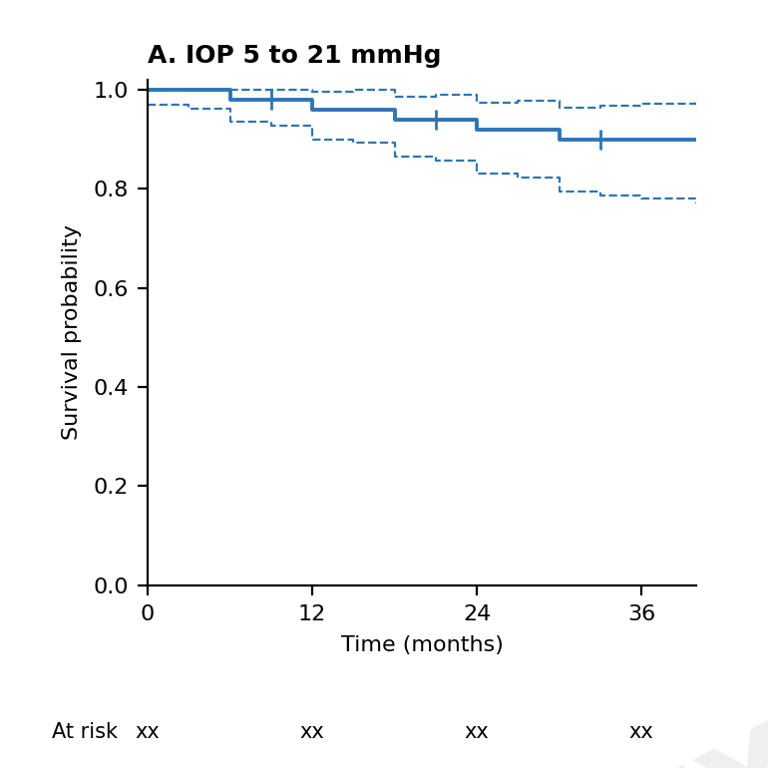

FIGURE 2. Scatter plot of logMAR visual acuity at baseline against the last follow-up visit, one point per eye. The line marks no change. CF, counting fingers; HM, hand motion; LP, light perception (placed according to the logMAR convention chosen for CF, HM, LP and NLP).
